CHAPTER 1: INTRODUCTION

1.1 Background Information
The motivation behind this project is to accurately detect and identify potato leaf diseases using advanced technologies. Human eyes often struggle to identify these diseases accurately, but Convolutional Neural Networks (CNNs) have shown remarkable performance in this area. Pre-trained neural network architectures can achieve an error rate as low as 3%, which outperforms the 5.1% top-5 error rate reported for human eyesight on large-scale image datasets. This highlights the potential of CNNs in providing reliable disease detection solutions for agriculture.

1.2 Problem Statement
Potato farmers face significant financial losses annually due to diseases that affect their crops. The most common diseases, Early Blight and Late Blight, are caused by fungal infections and specific microorganisms, respectively. Early identification and appropriate treatment of these diseases can save farmers considerable time and resources. Since the treatments for Early Blight and Late Blight differ, precise diagnosis is critical.
Diseases impact various parts of the plant, including leaves, stems, roots, and fruits, ultimately affecting both the quality and quantity of the crop. This, in turn, contributes to food insecurity and economic instability worldwide. Traditional diagnosis methods, such as visual estimation, rely heavily on the farmer’s experience, making them inconsistent and unreliable.
Modern methods, such as spectrometer analysis, enable rapid and accurate diagnosis without human intervention. Machine learning, particularly deep learning, has emerged as a powerful tool in agriculture, contributing significantly to efforts aimed at increasing productivity and sustainability. Among the various deep learning architectures, CNNs stand out for their efficiency in image data analysis. By leveraging multilayer convolutional networks, CNNs require fewer neurons than Artificial Neural Networks (ANNs) while offering superior feature learning capabilities, especially with large datasets.

1.3 Objectives of the Study

1.3.1 General Objective
To develop a system that efficiently and accurately detects whether potato plant leaves are healthy or infected, and provides appropriate remedies for detected diseases.

1.3.2 Specific Objectives
- Design a system capable of accurately detecting, diagnosing, and classifying potato leaf diseases.
- Develop a system that recommends effective solutions for detected potato diseases.
- Enable users to upload potato leaf images to the system using a camera for analysis.

1.4 Justification for the Study
This study contributes to the growing intersection of agriculture and cutting-edge technology. By applying deep learning techniques, particularly CNNs, the research advances agricultural productivity and enhances knowledge in computer science. A system that ensures accurate detection and identification of potato leaf diseases offers significant benefits to farmers, reducing crop losses and improving food security. Moreover, the research has broader implications for addressing global agricultural challenges.

1.5 Scope
The study focuses on Kenyan potato farmers, addressing challenges faced by both small-scale and large-scale growers. By providing a technology-driven solution, this project aims to mitigate critical issues associated with potato farming, ultimately improving yield quality and economic outcomes.

CHAPTER 2: LITERATURE REVIEW

2.1 Introduction
The identification and classification of plant diseases have been extensively researched using various approaches. Despite significant progress, the field remains an area of active development with substantial potential for further exploration. Deep learning methods, in particular, have demonstrated exceptional performance in visual perception tasks such as object detection, text recognition, and target tracking. These capabilities make deep learning an ideal solution for robust classification of leaf diseases, accommodating variations in pose, color, scale, and deformable objects.

2.2 Related Work

Case 1: Krishi Mitra
In the study titled “Krishi Mitra: Using Machine Learning to Identify Diseases in Plants,” a CNN model implemented with TensorFlow Framework was employed. The model excelled in detecting fungi-caused diseases in sugarcane by calculating leaf area. However, the approach required high computational complexity, presenting a potential limitation.

Case 2: Srdjan Sladojevic et al.
This research proposed a CNN-based method for recognizing diseases in five types of plants and 13 distinct diseases. The model achieved an average accuracy of 96.3%, demonstrating its effectiveness. The results underscore CNN’s potential for multi-class disease detection.

Case 3: Potato Late Blight Severity Identification
A study focused on identifying the severity of Late Blight in potato crops using Fuzzy C-Mean Clustering Neural Network. The dataset included images taken from various angles by untrained farmers, enhancing model usability. However, challenges arose from non-oriented images containing background clutter.

Case 4: Tomato Leaf Disease Detection
Researchers employed Mask R-CNN for detecting infectious areas in tomato leaves. This approach improved pathogen detection speed and accuracy. Nonetheless, it incurred longer processing times, which could hinder real-time applications.

Case 5: Backpropagation Neural Network
Jobin Francis et al. utilized Backpropagation Neural Networks alongside Gray Level Co-occurrence Matrix (GLCM) for feature extraction to classify pepper plant diseases. Diseases such as Berry Spot and Rapid Disease were accurately detected, achieving an accuracy rate of 96.76%.

2.3 Synthesis of Related Work
The reviewed studies highlight the efficacy of CNN and other neural network architectures in plant disease detection. However, limitations such as computational complexity, processing time, and image orientation issues remain prevalent. This project addresses these gaps by optimizing CNN architecture and incorporating robust preprocessing techniques tailored to potato leaf images.

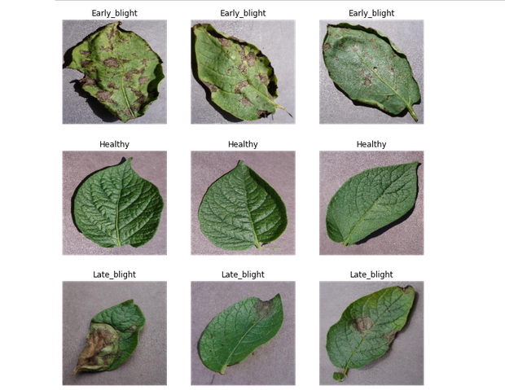
Examples of potato leaf images: early blight, healthy, and late blight.

CHAPTER 3: METHODOLOGY

3.1 Introduction
This chapter outlines the methodology used in the development of the system. It includes details on the adopted methodology, data collection, preprocessing techniques, CNN architecture, and evaluation metrics. The Rapid Application Development (RAD) methodology was employed to ensure iterative progress and adaptability throughout the project lifecycle.

3.2 System Development Methodology
The system development process followed the Rapid Application Development (RAD) methodology, focusing on iterative development and rapid prototyping. The primary steps included:
- Dataset Preparation: The Potato Leaf Images Dataset was downloaded from Kaggle and stored in Google Drive for easy access.
- Data Preprocessing: Techniques such as auto-orientation, resizing, and data augmentation were applied to enhance dataset quality.
- Model Training and Validation: The CNN model was trained and validated using Google Colab, leveraging the augmented dataset.
- Model Testing: The trained model was evaluated on a separate test set to ensure robustness and reliability.

3.3 Data Collection

3.3.1 PlantVillage Dataset
The PlantVillage dataset was utilized as the primary data source for this study. Developed by Penn State University and EPFL, the dataset contains 38 classes of diseased and healthy leaves from 14 plants. For this research, the focus was on potato crops, with the following distribution:
- Early Blight: 1,000 images
- Late Blight: 1,000 images
- Healthy: 152 images
Table 1: Summary of the PlantVillage dataset
 | PlantVillage Dataset
Class Labels |  | Samples
Early Blight |  | 1000
Late Blight |  | 1000
Healthy |  | 152
Total Samples |  | 2152

3.4 Image Preprocessing

3.4.1 Data Augmentation
To address overfitting and improve the diversity of the training set, various augmentation techniques were applied using the Keras ImageDataGenerator. These included:
- Rotation: Rotating images at specific angles.
- Shifting: Horizontal and vertical shifts with defined range values.
- Shear Transformation: Stretching one axis of the image to a specific angle.
- Zoom: Magnifying parts of the image.
- Flipping: Horizontally flipping images.
- Brightness Adjustment: Modifying brightness levels within a specified range.

3.5 Evaluation Metrics

3.5.1 Classification Accuracy
This metric is calculated as the ratio of correctly predicted samples to the total number of predictions.

3.5.2 Precision
Precision measures the consistency of the model in identifying true positives, especially important in imbalanced datasets.

3.5.3 Recall
This metric indicates the proportion of actual positives that the model correctly identifies.

3.5.4 F1 Score
The F1 Score combines precision and recall to provide a balanced evaluation of the model’s performance.

3.6 System Design
The proposed CNN model consists of three convolutional layers, each followed by Rectified Linear Unit (ReLU) activation and max-pooling layers. The final architecture includes:
- Flatten Layer: Converts the convolved matrix into a one-dimensional array.
- Fully Connected Layers: Three dense layers with ReLU activation, followed by an output layer with Softmax activation.
Table 2: Configuration Details of the CNN Model
The configuration details and various parameters of the proposed CNN are given in Table 2.

Convolution Layers 3 (with 3 × 3 filters/kernels each)
Max-Pooling Layers 3 (with (2, 2) pool sizes each)
Hidden Layer Neurons 512 (1st), 256 (2nd), 128 (3rd)
Output Layer
Activation Function Softmax
Batch size 32
Epochs 50
Training Optimizer Adam
Loss Function Categorical Cross Entropy
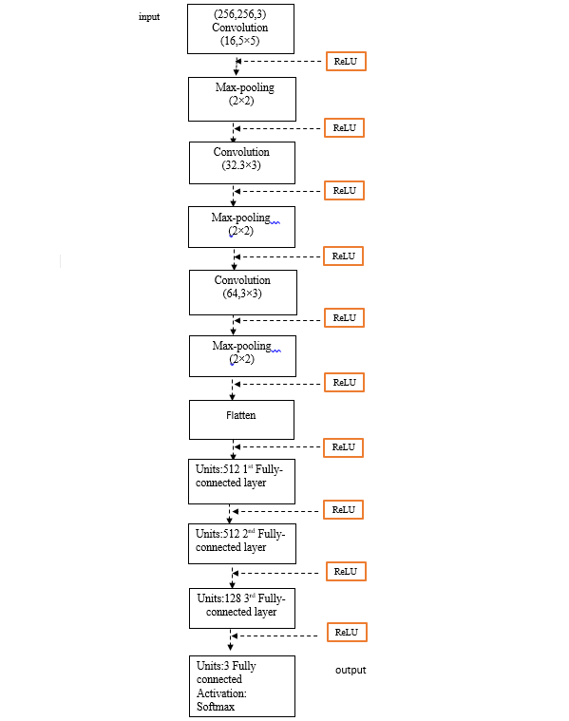
Figure 1:The architecture of the proposed CNN model.

3.7 Functional Requirements
- The system will accept potato leaf images via folder upload or camera input.
- It will detect, diagnose, and classify the uploaded images using the trained CNN model.
- Based on predictions, the system will recommend appropriate treatments for detected diseases.
- It will preprocess and clean data before running predictions on the validation dataset.

3.8 Non-Functional Requirements
- Performance: Ensure fast and reliable hosting platforms for smooth operation.
- Reliability: Maintain high accuracy and minimal system downtime.
- Usability: Ensure a user-friendly interface with consistent output display.
- Scalability: Optimize computing resources for faster model training and scalability.

